Change default identity

Flow diagram

Update default identity on IAM service
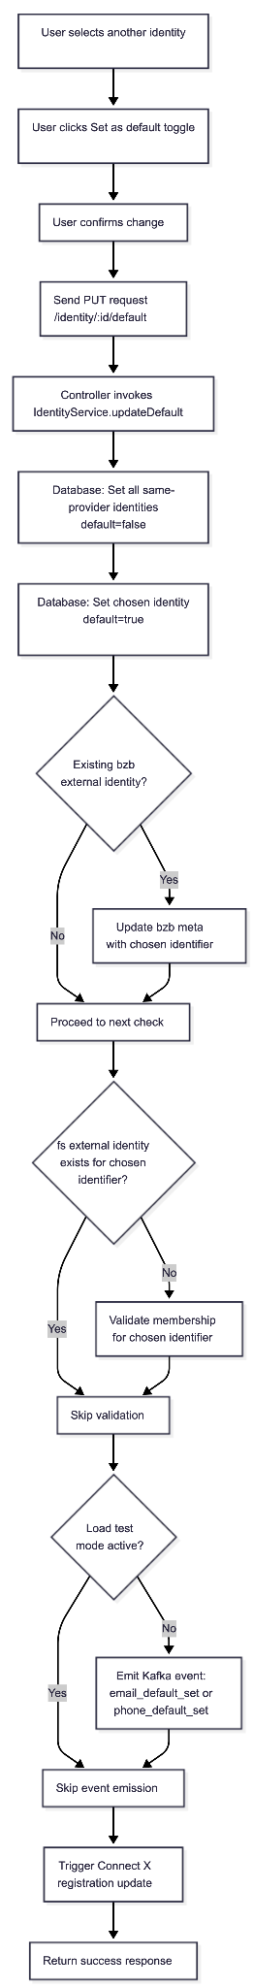

Update default identity on SSO service
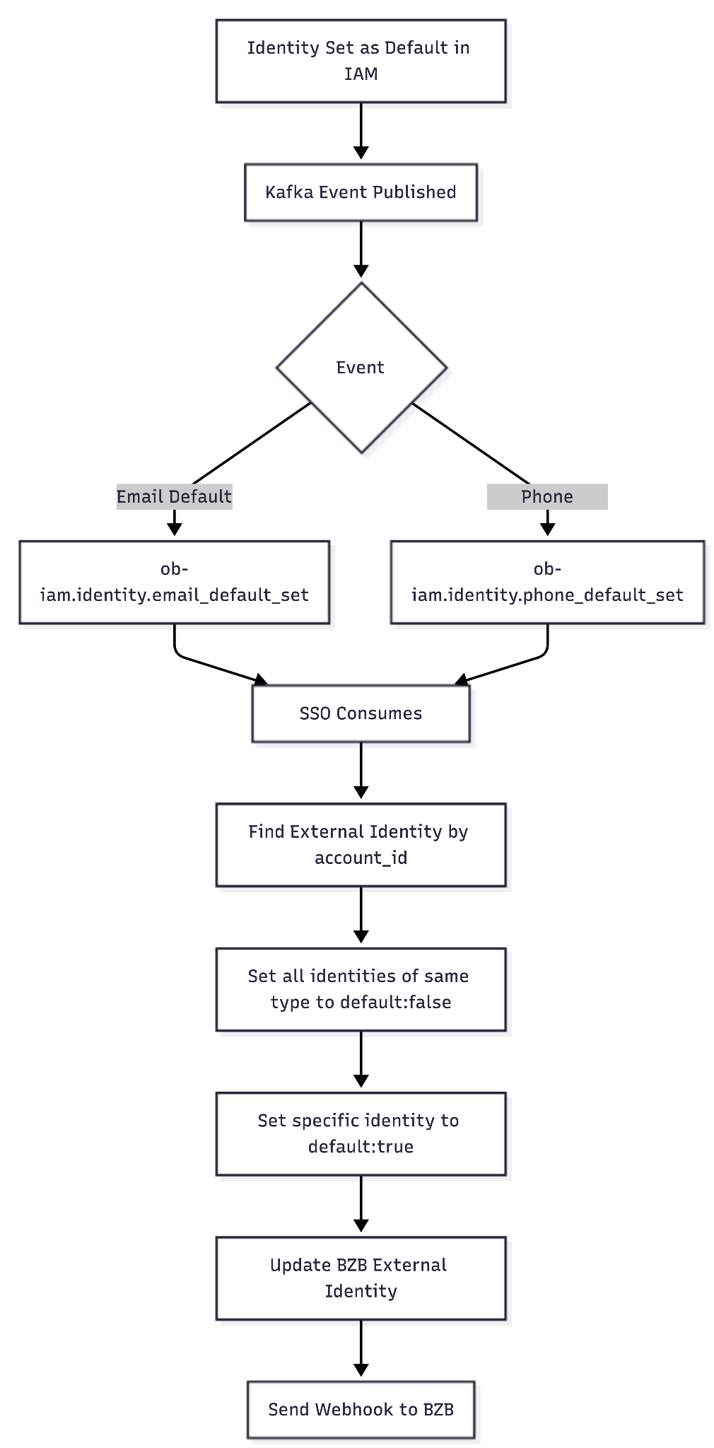

Send webhook to BZB service
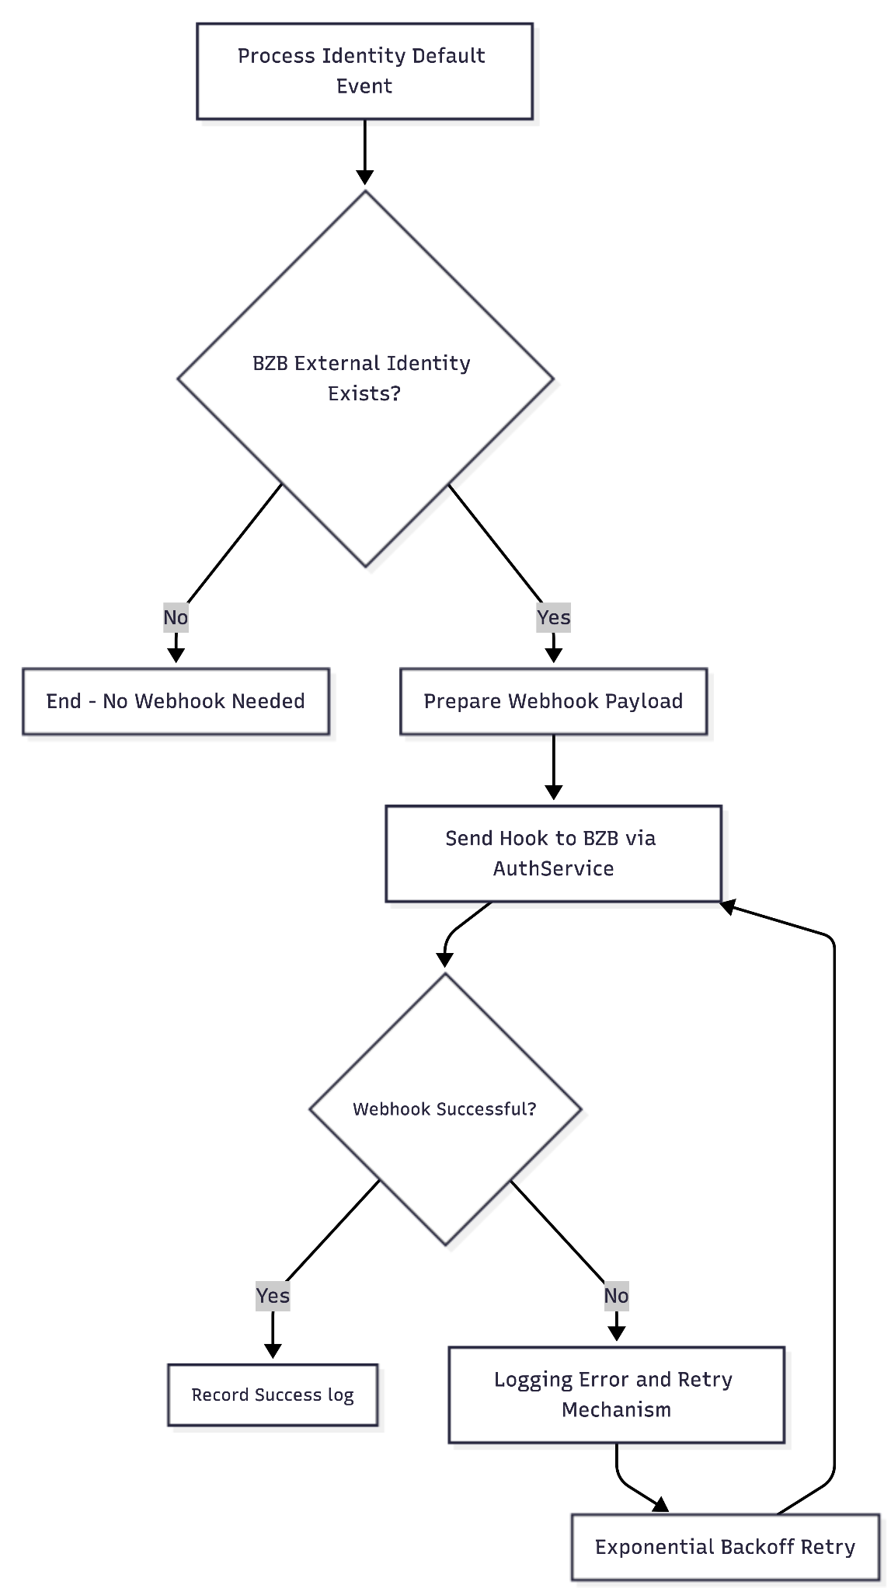

Preview Screen
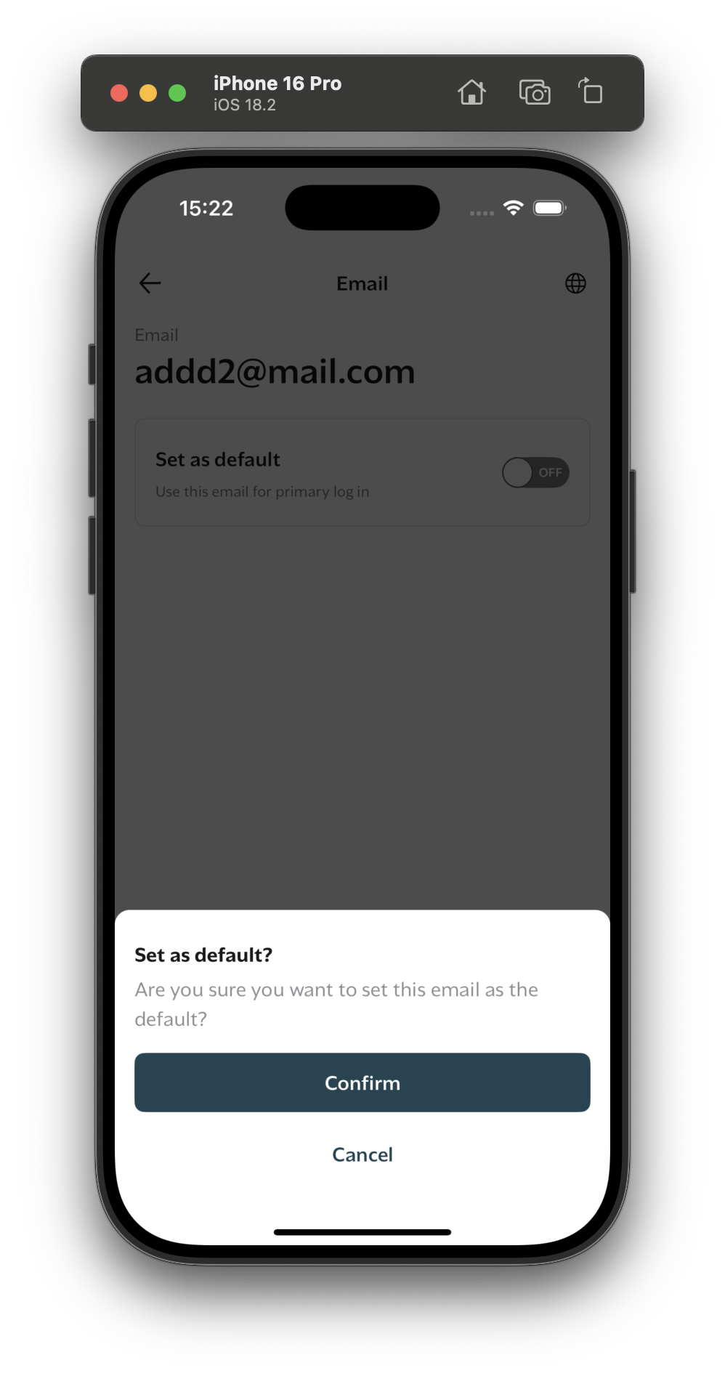

Sequence diagram

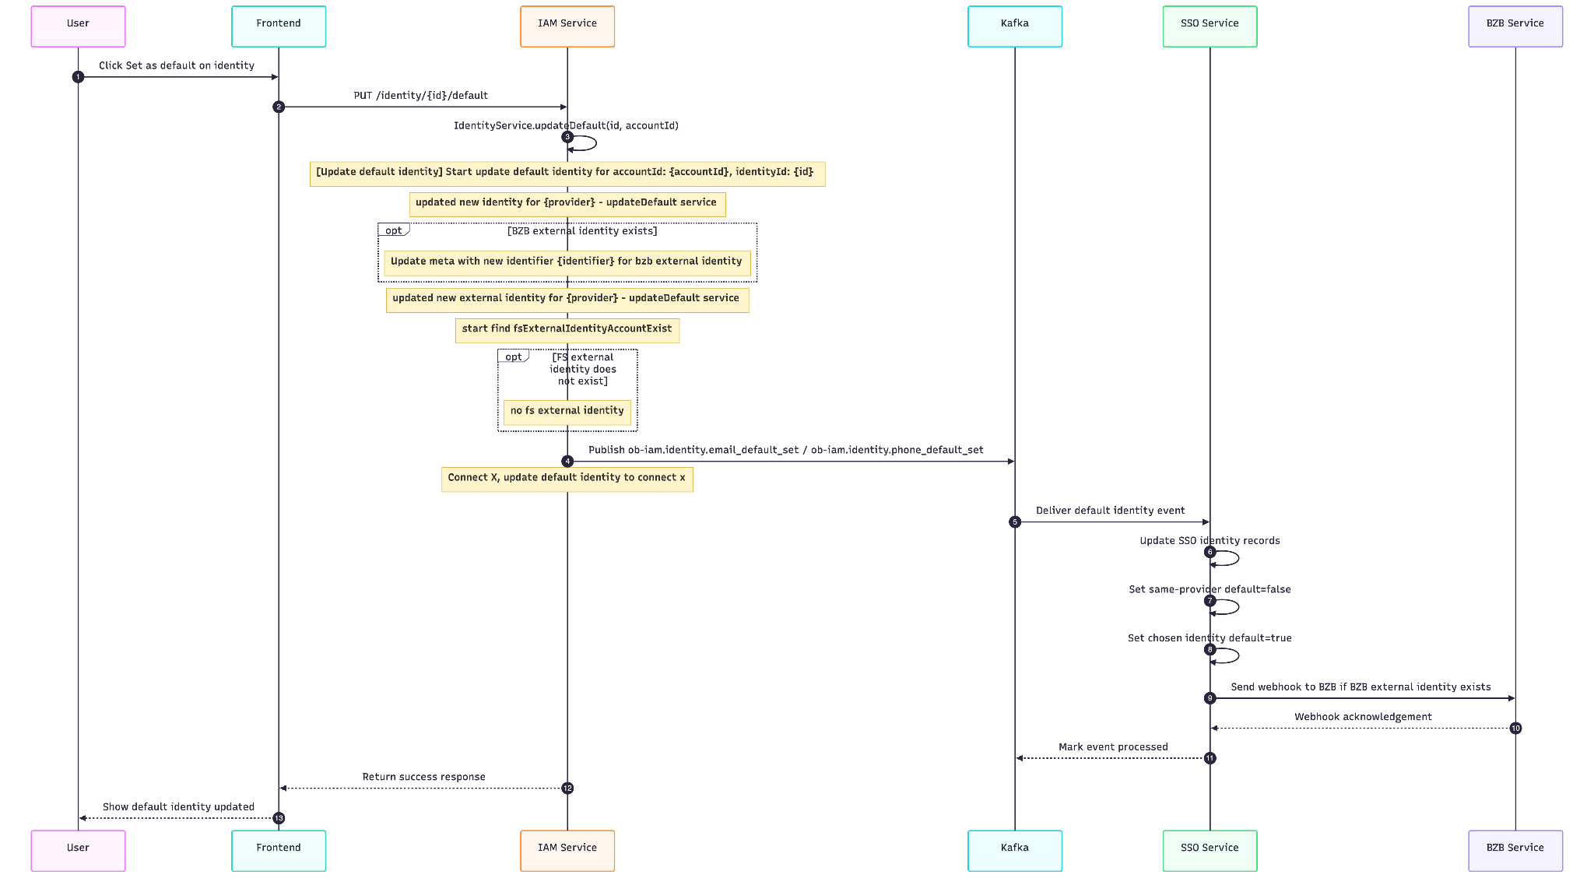

Api description

Update default identity - IAM

Description
Set a selected identity as the default identity for the current account.

Example Request
PUT /identity/{id}/default
Content-Type: application/json
x-account-id: {account-id}

Request header

Name | Required | Description
x-account-id | Yes | Account identifier for the authenticated user
Content-Type | Yes | application/json
app-version | No | Optional app version header used by SSO interceptor logic

Example response
{
"data": {
"result": true
}
}

Response detail
Result | Description
true | Update default identity success

Error scenarios
Error Code | HTTP Status | Description
IAM_IDT_005 | 404 | Identity not found for the requested account

Example Error Response
{
"error": {
"code": "IAM_IDT_005",
"message": "Identity not found",
"stack": "Error: Identity not found\n at ..."
}
}

Kafka Events: Identity Default Setting

Purpose
This event is published when a user designates a specific email identity as their default in the IAM system. The SSO system consumes this event to update its local identity records accordingly.

Event Structure

ob-iam.identity.email_default_set - Triggered when a user sets a default email identity
{
"name": "ob-iam.identity.email_default_set",
"payload": {
"account_id": "string",
"identity": {
"identifier": "string",
"provider": "string",
"default": "boolean"
}
}
}

ob-iam.identity.phone_default_set - Triggered when a user sets a default phone identity
{
"name": "ob-iam.identity.phone_default_set",
"payload": {
"account_id": "string",
"identity": {
"identifier": "string",
"provider": "string",
"default": "boolean"
}
}
}

Payload Details
Field | Type | Description
account_id | string | The IAM account ID associated with the identity
identity.identifier | string | The email address being set as default
identity.provider | string | The identity provider (typically "email")
identity.default | boolean | Flag indicating this is a default identity (always true for this event)

Webhook
The webhook is sent to the URI configured in the oauth_clients.hook_update_uri field for the BZB client.

HTTP Method
POST

Request Headers
Header | Value | Description
clientId | {client_id} | The OAuth client ID
Authorization | Bearer {bzb_access_token} | BZB access token (only for BZB client)

Request Body
{
"accessToken": "string",
"refreshToken": "string",
"meta": {
"{provider_name}": "string"
},
"publicId": "string"
}

Request Body Fields
Field | Type | Description
accessToken | string | JWT access token for the account
refreshToken | string | JWT refresh token for the account
meta | object | Metadata containing external identity provider mappings
publicId | string | Public identifier for the account

Cache Keys

Key | TTL | Source | Purpose
EXTERNAL_IDENTITY_CACHE_KEY_KEY_{accountId} | 3600 seconds | ExternalIdentityService | Stores external identity cache keys for an account so they can be invalidated together.
EXTERNAL_IDENTITY_CACHE_KEY_account_id_{accountId} | 3600 seconds | ExternalIdentityService.GetExternalIdentity | Cached external identities by account ID. Deleted when BZB external identity metadata is updated.
EXTERNAL_IDENTITY_CACHE_KEY_identifier_{identifier} | 3600 seconds | ExternalIdentityService.GetExternalIdentity | Cached external identities by identifier. Deleted through the account key registry.
EXTERNAL_IDENTITY_CACHE_KEY_uid_{uid} | 3600 seconds | ExternalIdentityService.GetExternalIdentity | Cached external identities by external UID. Deleted through the account key registry.
CNX_ACCESS_TOKEN | 3540 seconds | CNXClient | Cached Connect X access token used by Connect X registration/update calls.

